**Lower 3 Mandarin – where are you?**

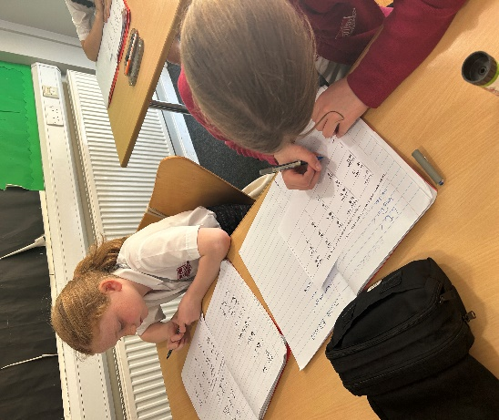

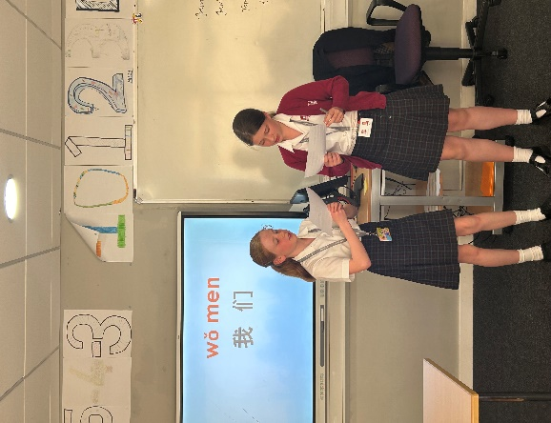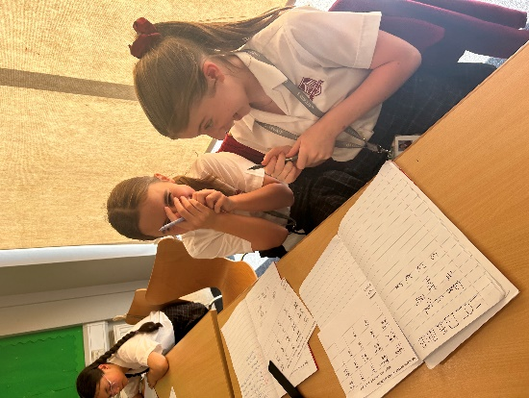

In our Lower 3 Mandarin class this week, we reviewed the theme of ‘location’. Pupils paired up, taking turns asking and answering questions about their whereabouts using terms like "go, in, on, at, there, and here." Additionally, we reinforced this topic through enjoyable computer games.

Mrs May Qingyan Day