**Silver and Gold Duke of Edinburgh practice expeditions**

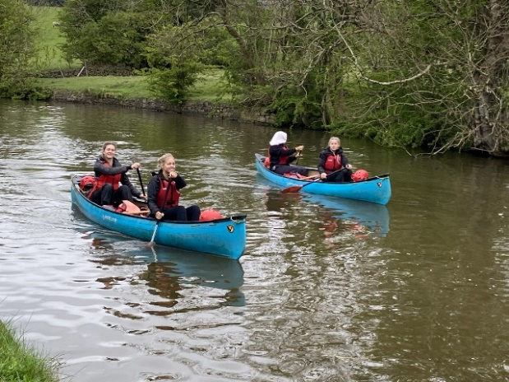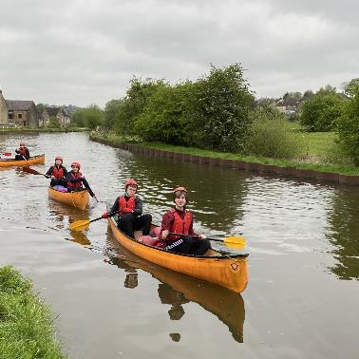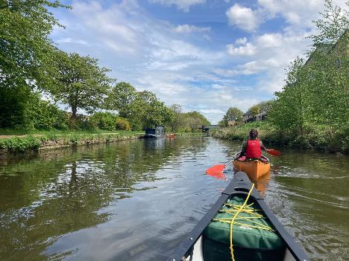

From the 3rd to the 5th of May, Upper 5 and Lower 6 participants embarked on a challenging journey as part of the Silver and Gold Duke of Edinburgh award. Their starting point was a campsite in the beautiful Yorkshire Dales, near Skipton, North Yorkshire.

The expedition commenced amidst a mix of excitement and determination. Despite the damp weather on arrival day, our pupils maintained high spirits as they swiftly set up camp.

The Gold participants had arrived earlier in the day and had wasted no time in honing their skills on the water, showcasing their resilience and passion for adventure. Meanwhile, the Silver participants double checked their routes for the following days where they would canoe down the tranquil waters of the Leeds Liverpool Canal.

As day two dawned, the pupils woke early and commenced cooking breakfast on their Trangia stoves. With tents dismantled and bags packed, they set off on their journey, paddling along the canal with their gear safely tucked into dry bags . It was a demanding day, but their perseverance and teamwork got them through it. That night we camped at Blackhills Scout Camp, going back to nature with only the most basic of luxuries at hand.

*Continued...*

On the final leg of their journey, anticipation filled the air as they approached Apperley Bridge marina - the end was in sight! Day three brought a mix of emotions as they eagerly anticipated the comforts of home – hot showers and their own beds being top of the list!

All the teams were given detailed feedback during this practice expedition and will now have to take on board these targets in order to attain the full award during their assessed expedition in June.

Mrs Colette McDermott